A PROJECT REPORT

CLI Based Maze Solver in Java using DFS Algorithm

Design and Analysis of Algorithms
23CSH-301

Submitted by

Himanshu Gupta (23BCS10889)

Submitted to

Mr. Mohammad Shaqlain (E17211)

in partial fulfillment for the award of the degree of

BACHELOR OF ENGINEERING

IN

COMPUTER SCIENCE & ENGINEERING

Chandigarh University

November 2025

BONAFIDE CERTIFICATE

Certified that this project report “CLI Based Maze Solver in Java using DFS Algorithm” is the bonafide work of “Himanshu Gupta” who carried out the project work under my/our supervision.

Mr. Mohammad Shaqlain (E17211)

SIGNATURE

TABLE OF CONTENTS

Sr. No. | Topic | Title / Description | Page
1. | Aim | To develop and analyze the complexity of a program to solve a maze using the Depth-First Search (DFS) and backtracking approach. | 4
2. | Objective | To implement a Maze Solver that finds a valid path from a start point (S) to an end point (E) in a 10×10 maze using recursive DFS and backtracking. | 4
3. | Input / Apparatus Used | Programming language (Java), IDE (IntelliJ IDEA), and a 10×10 maze represented as a 2D character array with S, E, ., and | 5
4. | Procedure / Algorithm | Step-by-step explanation of the Maze Solver algorithm using recursive DFS and the solveMaze(), isValidMove(), and printMaze() functions. | 6
5. | Functions Used | Description of all main functions: solveMaze(), isValidMove(), and printMaze(). | 6
6. | Flow of Control (Step-by-Step) | Explains the logical flow of program execution from input to output using backtracking. | 7
7. | Code | Complete Java implementation of the CLI-based Maze Solver using DFS algorithm. | 7
8. | Example Output | Displays sample input and the corresponding solved maze with the valid path marked using ‘*’. | 10
9. | Time and Space Complexity Analysis | Analyzes time complexity O(N²) and space complexity O(N²) for the DFS approach. | 11
10. | Advantages | Highlights the simplicity, visual clarity, and effectiveness of the recursive approach. | 11
11. | Disadvantages | Discusses limitations such as non-optimal pathfinding and high recursion depth for large mazes. | 11
12. | Applications | Lists practical uses in robotics, AI, games, and educational problem-solving. | 12
13. | Conclusion / Result | Summarizes the success of the CLI-based Maze Solver, emphasizing recursion, backtracking, and algorithmic design principles in Java. | 12

1. Aim
To develop and analyse the complexity of a program to solve a maze using the Depth-First Search (DFS) and backtracking approach.

2. Objective
The objective is to implement a Maze Solver that finds a valid path from a start point (S) to an end point (E) in a 10×10 maze using recursive DFS.
The program ensures:
- Only valid cells (. or E) are visited.
- Walls (|) are avoided.
- The solver backtracks when it reaches a dead end.
- The path found is marked with *.

3. Input / Apparatus Used
Programming Language: Java
IDE Used: IntelliJ IDEA
Input:
A 10×10 maze represented as a 2D character array:
- S → Start position
- E → End position
- . → Path (movable cell)
- | → Wall (blocked cell)

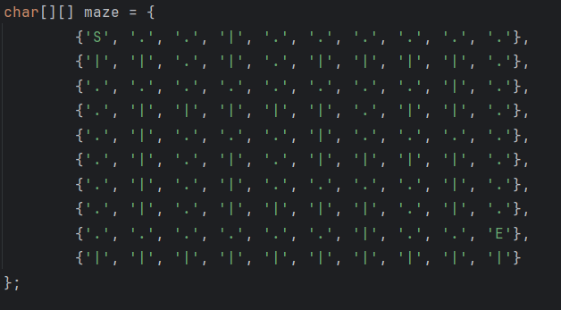

4. Procedure / Algorithm
Algorithm: Maze Solver using Backtracking

- Start
- Read or define the 2D maze grid.
- Locate the Start (‘S’) position in the maze.
- Call the recursive function solveMaze(maze, startRow, startCol).
- Inside solveMaze():
  - If the current cell is the end cell (E), return success.
  - If the current cell is a valid move (. or S):
    - Mark it with * (visited path).
    - Recursively explore all four directions using isValidMove():
      - Move Up: (row - 1, col)
      - Move Down: (row + 1, col)
      - Move Left: (row, col - 1)
      - Move Right: (row, col + 1)
    - If any recursive call returns true, the path is found.
    - Otherwise, backtrack by restoring the original cell value.
- Continue until the maze is solved or no valid path exists.
- Display the maze using printMaze().
- Stop

5. Functions Used
Function Name | Description
solveMaze(char[][] maze, int row, int col) | Recursively explores all possible paths using DFS and marks visited cells.
isValidMove(char[][] maze, int row, int col) | Checks if the next cell is within maze boundaries and not a wall (`
printMaze(char[][] maze) | Prints the maze grid neatly before and after solving.

6. Flow of Control (Step-by-Step)
- Start program execution.
- Display the original maze using printMaze().
- Find the position of S.
- Call solveMaze(maze, startRow, startCol).
- In solveMaze():
  - Check all four directions (up, down, left, right).
  - If a valid path is found, mark and continue.
  - If dead end → backtrack.
- Stop when E is reached or no path exists.
- Display final maze showing the solved path (*).

7. Code

public class MazeSolver {
static int rows, cols;
public static void main(String[] args) {
System.out.println("=== MAZE SOLVER ===");
System.out.println("S = Start, E = End, | = Wall, . = Path\n");
// maze
char[][] maze = {
{'S', '.', '.', '|', '.', '.', '.', '.', '.', '.'},
{'|', '|', '.', '|', '.', '|', '|', '|', '|', '.'},
{'.', '.', '.', '.', '.', '.', '.', '.', '|', '.'},
{'.', '|', '|', '|', '|', '|', '.', '|', '|', '.'},
{'.', '|', '.', '.', '.', '|', '.', '.', '.', '.'},
{'.', '|', '.', '|', '.', '|', '|', '|', '|', '.'},
{'.', '|', '.', '|', '.', '.', '.', '.', '|', '.'},
{'.', '|', '.', '|', '|', '|', '|', '.', '|', '.'},
{'.', '.', '.', '.', '.', '.', '|', '.', '.', 'E'},
{'|', '|', '|', '|', '|', '|', '|', '|', '|', '|'}
};
rows = maze.length;
cols = maze[0].length;
System.out.println("--- Original Maze ---");
printMaze(maze);
// starting position (S)
int startRow = -1, startCol = -1;
for (int i = 0; i < rows; i++) {
for (int j = 0; j < cols; j++) {
if (maze[i][j] == 'S') {
startRow = i;
startCol = j;
break;
}
}
}
System.out.println("\nSolving maze...");
boolean pathFound = solveMaze(maze, startRow, startCol);
if (pathFound)
System.out.println("\nPath Found!");
else
System.out.println("\nNo Path Found!");
System.out.println("\n--- Final Maze ---");
printMaze(maze);
}
// Recursive DFS Maze Solver
public static boolean solveMaze(char[][] maze, int row, int col) {
// base case
if (maze[row][col] == 'E') return true;
if (maze[row][col] == '.' || maze[row][col] == 'S') {
char original = maze[row][col];
maze[row][col] = '*'; // mark as part of path
// Move UP
if (isValidMove(maze, row - 1, col)) {
if (solveMaze(maze, row - 1, col)) return true;
}
// Move DOWN
if (isValidMove(maze, row + 1, col)) {
if (solveMaze(maze, row + 1, col)) return true;
}
// // Move RIGHT
// if (isValidMove(maze, row, col + 1)) {
// if (solveMaze(maze, row, col + 1)) return true;
// }
// Mai right phele explore kar raha hu ya baad me isse path ka phrk pd raha hai since
// more than one paths are existing
// Move LEFT
if (isValidMove(maze, row, col - 1)) {
if (solveMaze(maze, row, col - 1)) return true;
}
// Move RIGHT
if (isValidMove(maze, row, col + 1)) {
if (solveMaze(maze, row, col + 1)) return true;
}
// Backtrack
maze[row][col] = original;
}
return false;
}
public static boolean isValidMove(char[][] maze, int row, int col) {
return row >= 0 && row < rows &&
col >= 0 && col < cols &&
(maze[row][col] == '.' || maze[row][col] == 'E');
}
public static void printMaze(char[][] maze) {
for (char[] line : maze) {
for (char cell : line) {
System.out.print(cell + " ");
}
System.out.println();}}}

- Example Output
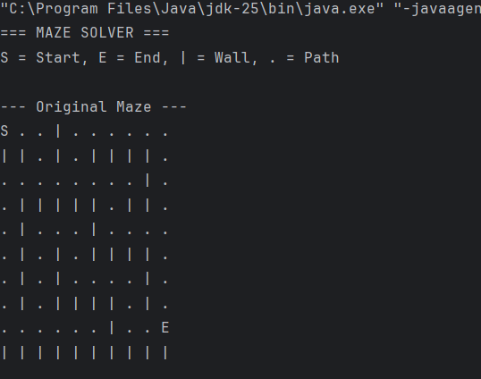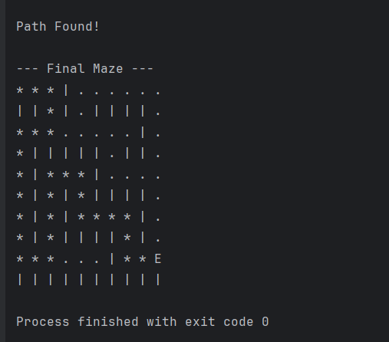

- Time and Space Complexity Analysis
Time Complexity:
Each cell is visited once in the worst case →
$$O(N^{2})$$
Space Complexity:
The recursion stack may go up to all accessible cells →
$$O(N^{2})$$
where N × N is the maze size.
10. Advantages
- Simple and intuitive recursive approach.
- Easy to visualize and implement in CLI.
- Demonstrates the concept of backtracking effectively.

11. Disadvantages
- Not guaranteed to find the shortest path.
- High recursion depth for large mazes.
- May explore redundant paths before reaching the end.

12. Applications
- Pathfinding in robotics and games.
- AI-based maze and puzzle solvers.
- Network routing and navigation algorithms.
- Teaching recursion and backtracking concepts.

13. Conclusion / Result
The CLI-based Maze Solver successfully identifies a valid path from the start (S) to the end (E) using the Depth-First Search (DFS) technique.
The recursive function solveMaze() effectively explores all possible moves, validates each step with isValidMove(), and visualizes the result with printMaze().
This project demonstrates the power of recursion, backtracking, and structured problem-solving in Java.

